BRENT GOOSE OUT FOR A WALK JOIN HIM ON SUNDAY 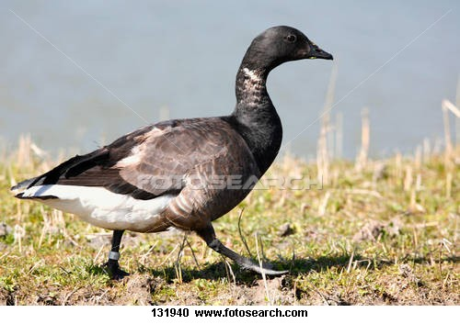
AN TAISCE

WELCOME OUR WINTER BIRDS AS THEY ARRIVE AFTER THEIR LONG JOURNEY FROM THE ARTIC CIRCLE

COME TO OUR BIRD WALK AND TALK WITH SEAN HOGAN OF BIRDWATCH IRELAND ON SUNDAY OCTOBER 16TH AT
10.30AM. MEET AT THE DART
car park in Booterstown.
ALL WELCOME
INFO: 087 9537959

